APPENDIX A
PHOTOGRAPHS TAKEN DURING JIV AT 6” TUOMO/OGBOINBIRI PIPELINE AT AZAMA COMMUNITY, SOUTHERN IJAW L.G.A, BAYELSA STATE ON 23RD JUNE, 2024.
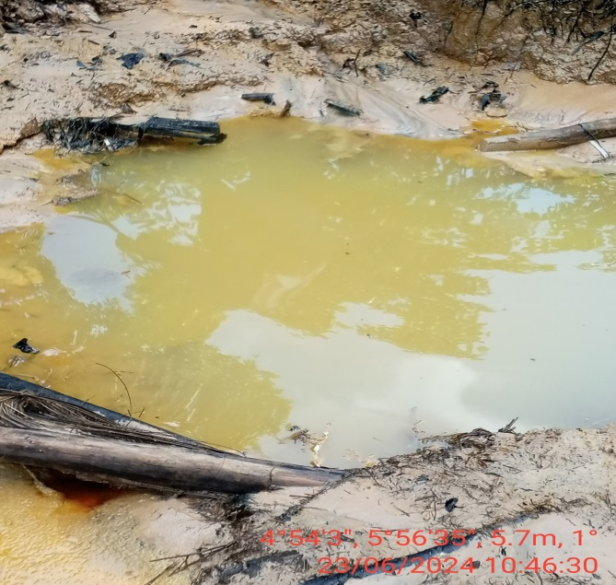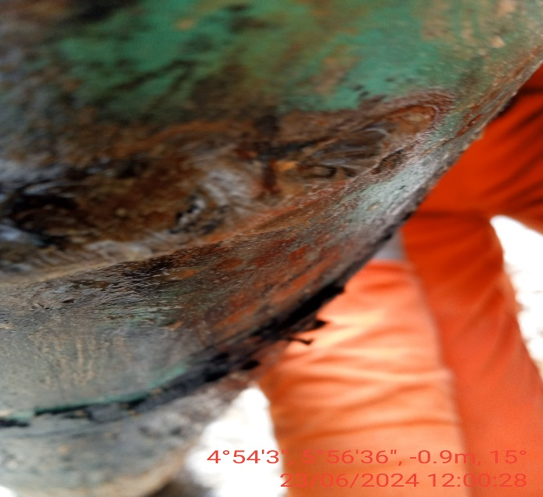
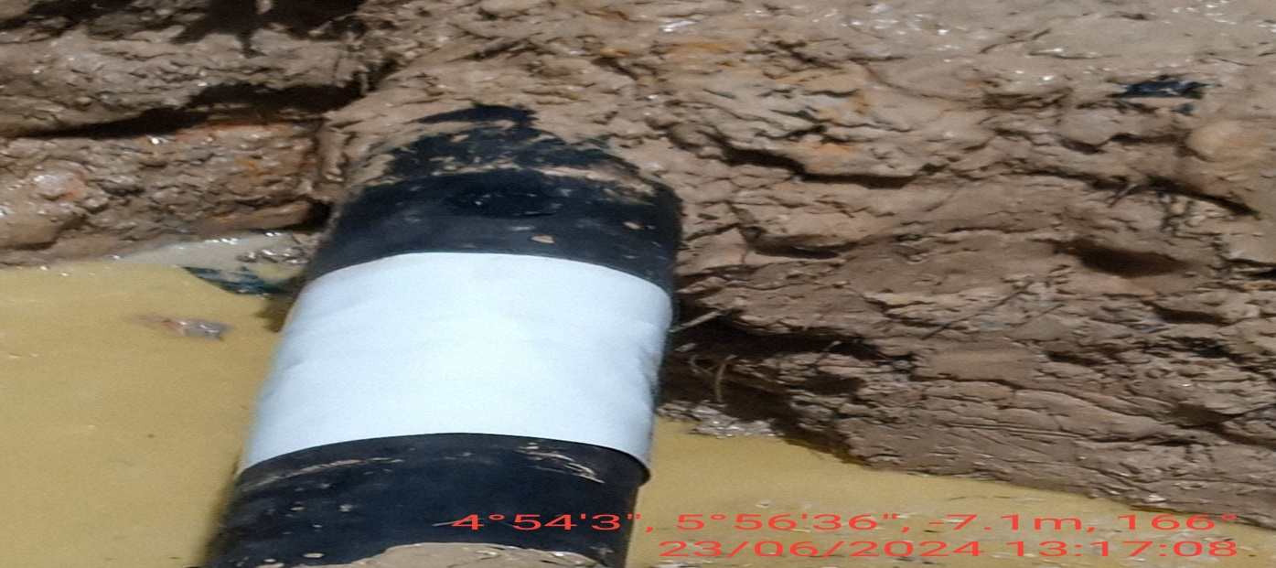
FIG.1: (L-R) THE INCIDENT POINT BEFORE EXCAVATION.
FIG.2: VANDALS USED A POINTED DEVICE TO MAKE A PUNCTURE AT 6 O’ CLOCK POSITION OF THE PIPELINE.
FIG.3: THE INCIDENT POINT AFTER REPAIRS AND WRAPPING.

